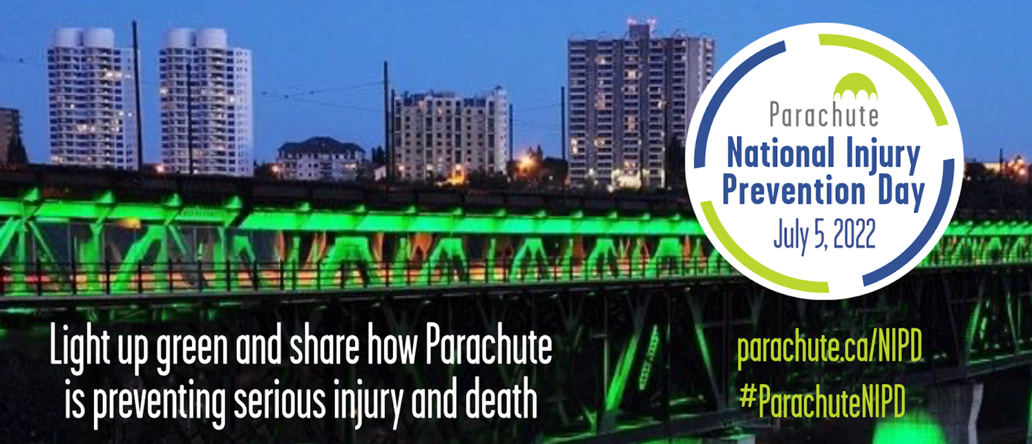

2022 #ParachuteNIPD Social Media Guide

On Tuesday, July 5, 2022, Parachute will celebrate the sixth National Injury Prevention Day in Canada to raise awareness about the devastating effects of predictable and preventable injuries.

This guide is to help communities and partners use social media to support and promote Parachute’s National Injury Prevention Day.

Who is this guide for?
This guide is for all community leaders and partners who use social media tools or online communication media in a professional capacity, including, but not limited to, the following: Facebook, Twitter, Instagram, LinkedIn, YouTube, or blogs.

Use hashtags!
Use hashtags in all social media channels to gain momentum and build a community of support leading up to July 5, on the day itself, and after.

Primary hashtag: #ParachuteNIPD Secondary hashtag: #TurnSafetyOn

You can also create your own hashtags, but we urge you to use #ParachuteNIPD in all posts.

How do we engage?
Follow us and comment, share, like and re-post relevant content. We’ll be doing the same, with as many of you as possible, leading up to, during and after #ParachuteNIPD!

When should we start posting?
Start posting and tweeting about #ParachuteNIPD any time! We want to boost the number of people who are aware of Parachute’s National Injury Prevention Day and start engaging your community partners and the public as soon as possible.
Other content ideas: Quotes from your community leaders (e.g., Mayor, Safe Community, local emergency worker)

Sample tweets
Below are sample tweets you can use on your channels. You’re also welcome and encouraged to come up with your own tweets and messages that make most sense for your organization and your community. Please note that a tweet can only be 280 characters long.

Before the date of #ParachuteNIPD

DYK that injury is the #1 cause of death of Canadians ages 1 to 44? Or that injury costs the Canadian economy $29.4 billion a year? Learn more about #ParachuteNIPD at parachute.ca/nipd & spread the word about injury prevention! #TurnSafetyOn | 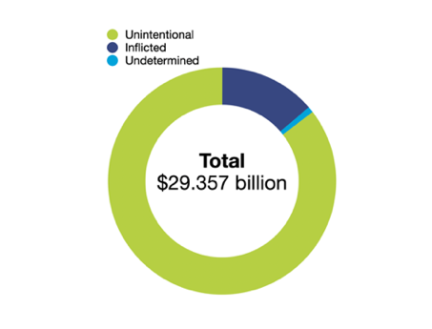
Preventable injury kills more Canadian children than any disease, and more youth than all other causes combined. On July 5, 2022, landmarks across Canada will be lit up in Parachute green to support #ParachuteNIPD! More: parachute.ca/nipd | 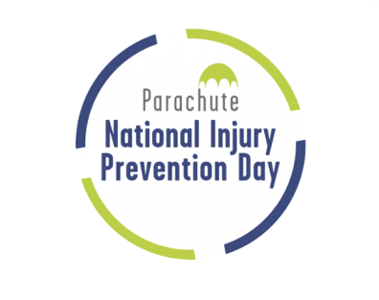
Participate in #ParachuteNIPD on July 5, 2022, to shine the light on predictable and preventable injuries! #TurnSafetyOn parachute.ca/nipd

#ParachuteNIPD brings an opportunity to shine a light on the preventability of injuries! We encourage hospitals across Canada to participate in our #HospitalChallenge to show the collective strength & collaboration across the country. #TurnSafetyOn parachute.ca/nipd
What could your program or hospital do with $1 million? You may spend that now on treating preventable injuries. Take up our challenge to prevent injuries & free up resources for other critical needs. More about #ParachuteNIPD at parachute.ca/nipd #TurnSafetyOn | 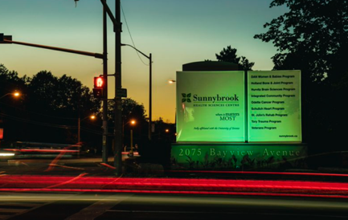
Join the conversation using #ParachuteNIPD and #TurnSafetyOn to help us spread the word about injury prevention. Learn more at parachute.ca/nipd | 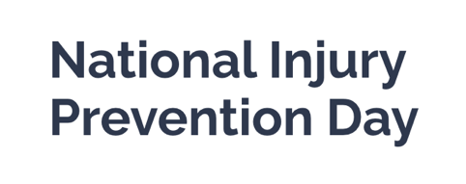
On July 5, 2022, major landmarks and hospitals across Canada will be lit up in Parachute green to support National Injury Prevention Day! #ParachuteNIPD #TurnSafetyOn parachute.ca/nipd | 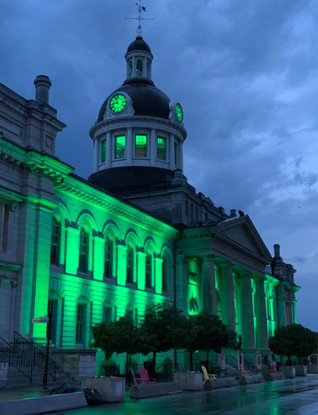
Most injuries are predictable and preventable: We need your help spreading our information on preventing serious injuries on the road, at home and at play. Learn more parachute.ca/nipd & join the conversation using #ParachuteNIPD

On July 5, 2022 - #ParachuteNIPD

Injuries cost the Canadian economy $29.4 billion a year. The cost of pain and suffering to individuals, families and communities is immeasurable. Learn more at parachute.ca/nipd #ParachuteNIPD | 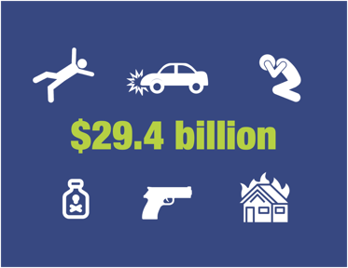
Injury costs $29.4 billion and more than 17,000 lives a year. We have the potential to change the story. Learn more: parachute.ca/nipd #ParachuteNIPD | 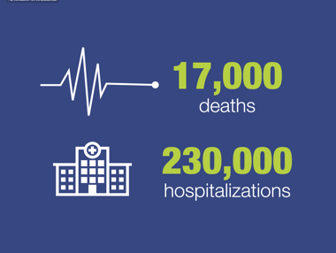
Injuries among children (ages 0-14) cost the Canadian economy $2.9 billion in 2018. Learn more at parachute.ca/nipd #ParachuteNIPD | 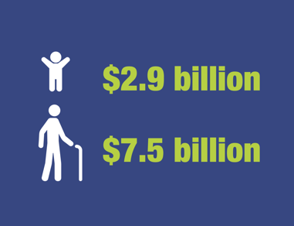
Falls and transport incidents had the highest total costs of any injury cause in 2018 at $13.8 billion, making up almost half of the cost of injury. Learn more at parachute.ca/nipd #ParachuteNIPD #CostOfInjury2021 | 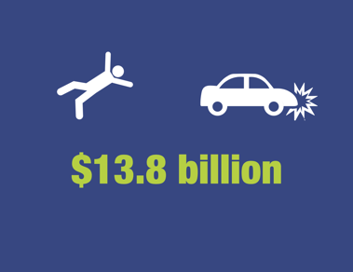
Most of the injuries that occur in Canada are preventable. We must take action to create a Canada free from serious injuries and deaths. Learn how this can be achieved at parachute.ca/nipd #ParachuteNIPD | 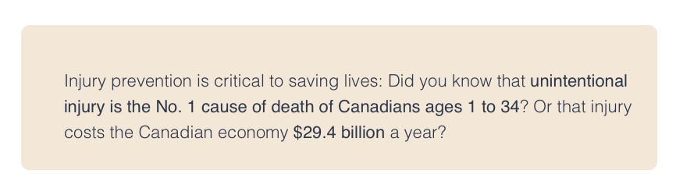
Preventable injury kills more Canadian children than any disease, and more youth than all other causes combined. Every day, 48 Canadians die & 634 are hospitalized because of injuries. Learn more at parachute.ca/nipd #ParachuteNIPD | 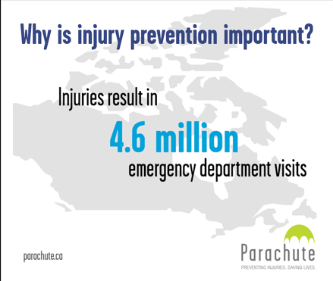
We have made improvements in injury prevention, but there’s still more work to do. Help us spread the message about the importance of injury prevention across Canada. parachute.ca/nipd #TurnSafetyOn #ParachuteNIPD | 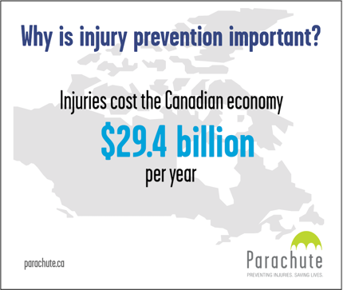

Post #ParachuteNIPD

#ParachuteNIPD has wrapped up, but #InjuryPrevention is important all year long! Visit @parachutecanada for info & tips: parachute.ca #TurnSafetyOn | 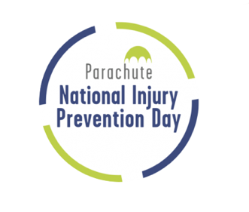

NIPD landmarks

Municipalities across the nation will show support for National Injury Prevention Day (NIPD) by lighting major landmarks in our distinctive “Parachute green” on July 5, 2022, to honour the initiative:

Halifax, NS, Halifax City Hall – @hfxgov Halifax City Hall will light up in Parachute ‘green’ to celebrate National Injury Prevention Day 2022! #ParachuteNIPD #TurnSafetyOn

Toronto, Ontario, CN Tower – @TourCNTower CN Tower shines Parachute ‘green’ for National Injury Prevention Day #ParachuteNIPD. Let’s reach an injury-free Canada! #ParachuteNIPD #TurnSafetyOn

Niagara Falls, ON, Niagara Falls – @NiagaraFalls (Niagara Falls Canada) Niagara Falls lights up Parachute ‘green’ in honour of National Injury Prevention Day! Help spread the word! #ParachuteNIPD #TurnSafetyOn

The Bastion, Nanaimo, BC – @ @NanaimoMuseum Vancouver City Hall celebrates National Injury Prevention Day by shining Parachute ‘green’. Let’s stop preventable injuries! #ParachuteNIPD #TurnSafetyOn

Kingston, Ontario, Kingston City Hall – @cityofkingston (City of Kingston) Kingston City Hall will light up Parachute ‘green’ to celebrate National Injury Prevention Day! #ParachuteNIPD #TurnSafetyOn

Vancouver, BC, Science World at TELUS World of Science – @scienceworldca Science World lights up Parachute ‘green’ to honour National Injury Prevention Day. Let’s raise awareness on injury prevention! #ParachuteNIPD #TurnSafetyOn

Legislature Assembly of New Brunswick, Fredericton - Legislature Assembly of New Brunswick will light up in Parachute ‘green’ to celebrate National Injury Prevention Day! #ParachuteNIPD #TurnSafetyOn

St. John’s City Hall, St. John’s - St. John’s City Hall lights up Parachute ‘green’ in honour of National Injury Prevention Day! Help spread the word! #ParachuteNIPD #TurnSafetyOn

City Hall Clock Tower, Moose Jaw - @CityofMooseJaw City Hall Clock Tower lights up Parachute ‘green’ in honour of National Injury Prevention Day! Help spread the word! #ParachuteNIPD #TurnSafetyOn

For the full list of landmarks go to parachute.ca/lightupcanada

Images
While we haven’t used any images in these sample posts, we encourage you take photos of the Canadian landmarks lit up and share them in your posts. Link to the #ParachuteNIPD 2022 image gallery: parachute.ca/lightupcanada

Ask Our Advice
If you have any questions or need some guidance, please feel free to direct them to Margarita at socialmedia@parachute.ca

